ML is a computer’s ability to learn without being explicitly programmed

Supervised Learning used most in real-world applications, been in rapid advancements lately
Logistic Regression might be the single most used classification algorithm in the world

There is also: Semi-Supervised learning, Reinforcement learning (… so, total 4 types; Is there 5th type? Self-supervised learning?)

Supervised Learning
There is input and output (label), ML algorithm tries to find relationship of the input to the output and thus producing a ML model. Basically, we have an equation like situation where we have x any y, and we should figure out the correct parameter (coefficient) for x’s, so that y becomes true for the given x’s.

One type of Supervised Learning is Regression where we try to predict continuous values [like price of a house based on its area].
There is another type of learning algorithm – Classification algorithm where we try to classify inputs to available outputs (categories; may be non-numeric). Classification predicts small, finite, limited number of possible outputs compared to Regression.
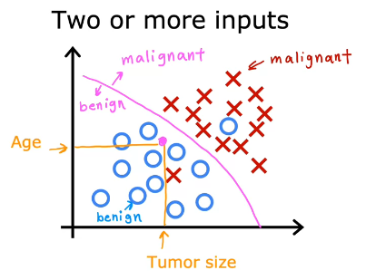

After learning on a training set the supervised learning algorithms will produce a function (also called hypothesis).
* Uni-variate linear regression – one variable linear regression like f(x) = wx + b

Commonly used cost function for linear regression and, for that matter for all the regression problems: Squared error cost function. The objective is to make cost function small.
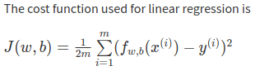
Gradient Descent is an optimization algorithm to minimize the cost function. Optimization continues until the algorithm converges, that’s where the w and b no longer change much with each additional step you take. Learning rate – tuning parameter in an optimization algorithm that determines the step size at each iteration while moving toward a minimum of a loss function. Near a local minimum: - derivative becomes smaller, - update steps become smaller.
When you have two or more derivatives of the same function, they are called a Gradient
Cost function (all of the training set) is summation of Loss functions (single example from the training set).
Gradient descent requires the derivative of the cost with respect to each parameter in the network. Neural networks can have millions or even billions of parameters. The back propagation algorithm is used to compute those derivatives. Computation graphs are used to simplify the operation.
Convex function (bowl-shape function; this is actually a cost function) has only the global minimum, it has no local minimum. So long is the learning rate chosen properly, the algorithm will always converge to the global minimum.

Creating a feature is an example of Feature Engineering. Say you have frontage and depth of a house, you can create feature (engineer a feature) called “area” out of frontage and depth.
Feature engineering – design of new features by transforming or combining original features.
Logistic regression utilizes sigmoid function
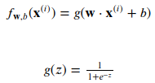

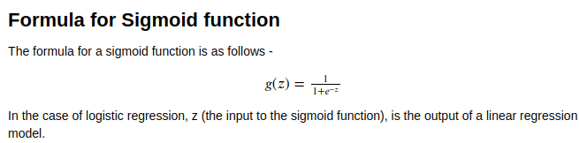

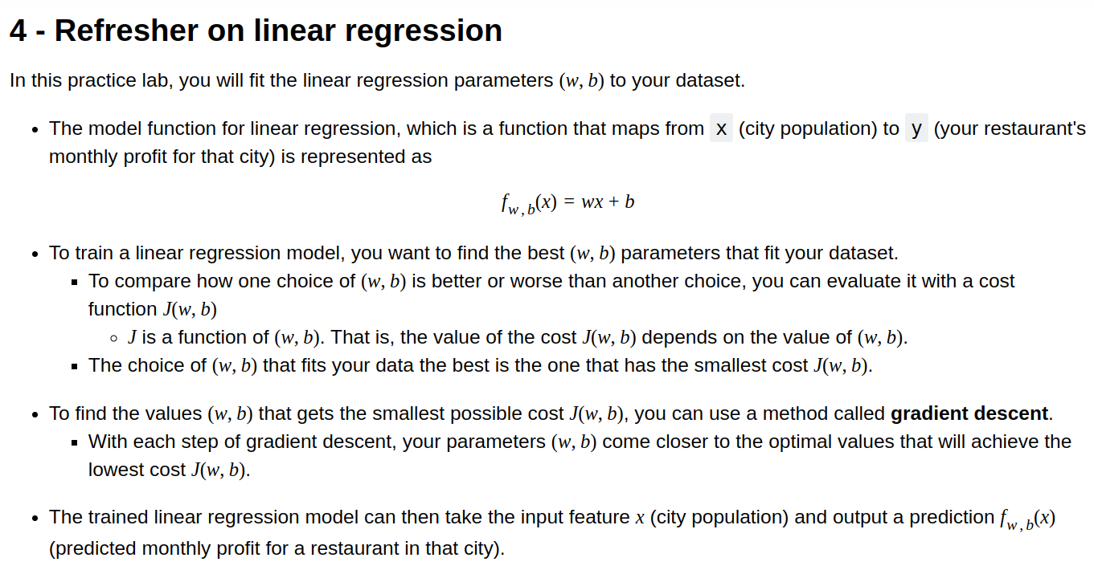
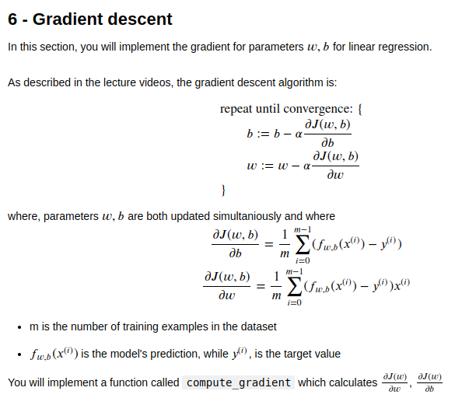

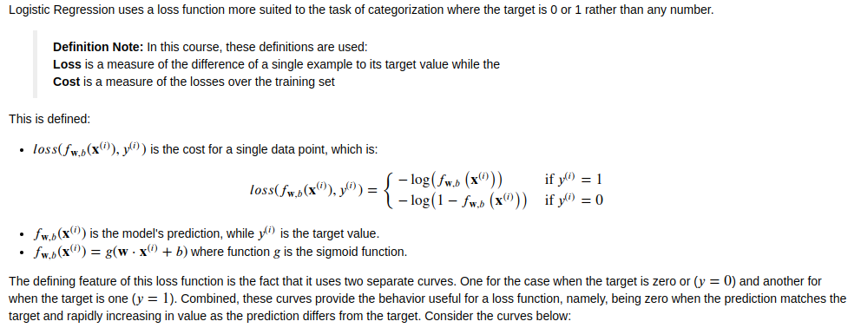
Regularization is a technique used in machine learning to prevent overfitting.

Regularization is a set of methods for reducing overfitting in machine learning models. Typically, regularization trades a marginal decrease in training accuracy for an increase in generalizability.

High bias – underfitting: J_train will be high, J_test will be high
High variance – overfitting: J_train will be low, J_test will be high

Bias and Variance are some of those concepts that take a short time to learn but a lifetime to master.
------------------------------------------------------
One way to reduce bias is to use bigger neural network
-------------------------------------------------------------------
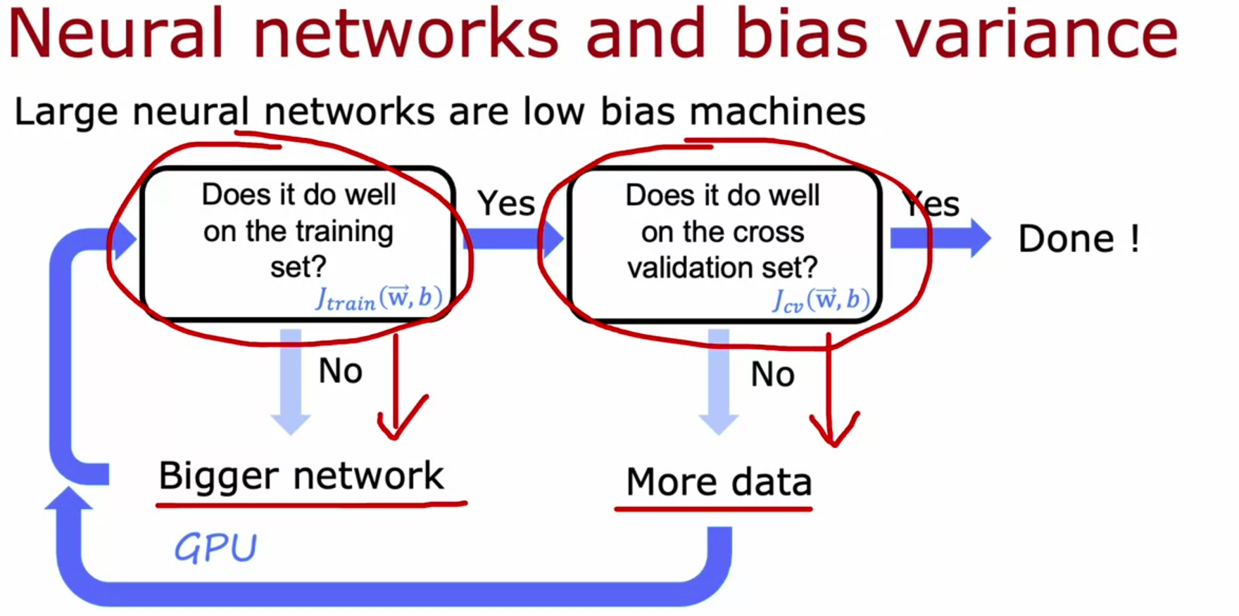

If a learning algorithm suffers from high variance, getting more training data is likely to help.
Underfitting == high bias
Overfitting == high variance
One way to address overfitting is to select features (include/exclude)
Regularization is a mechanism to minimize the cost function by applying (multiplying) what’s called ‘lambda’ (regularization parameter) to the parameters w_j.

------------------------------------------------------------------------------------------------------------------------
A large neural network will usually do as well or better than a smaller one so long as regularization is chosen appropriately.

Note that adding more examples when the model has high bias (underfitting) does not improve performance.
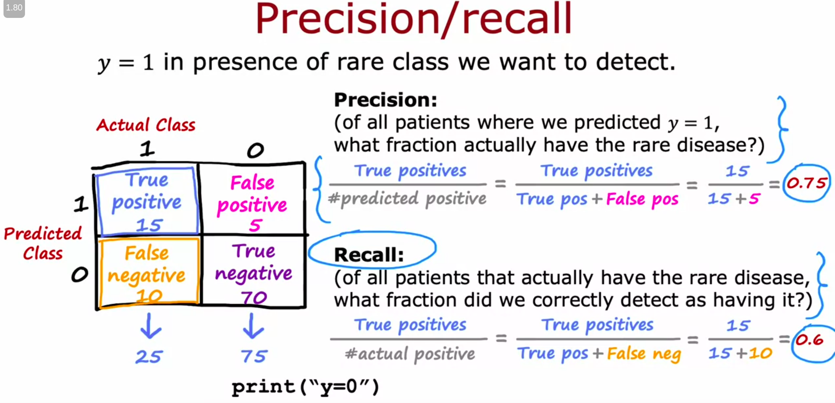

Error Analysis
Is sometimes helps to look at the errors of the alogirthm, to look to the actual data. You can collect more data on the cases where the algorithm has fallen most, this, hopefully will improve the accuracy of the algorithm.

Manually examine a sample of the training examples that the model misclassified in order to identify common traits and trends. By identifying similar types of errors, you can collect more data that are similar to these misclassified examples in order to train the model to improve on these types of examples.
Data Augmentation
Distortion introduced should be representation of the type of noise/distortions in the test set. It is usually does not help to add purely random/meningless noise to your data.
Transfer Learning
You take a very large dataset and train your neural network on the taken dataset. Then you copy the nn and apply it to classify digits from 0 to 10 for example. Doing so you transferred the weights and biases learned from training the initial large dataset and applied it to the new data. The you run an optimization algorithm with the gotten weights and biases as initial parameters.

Option 1: if you have very small training dataset then might opt for the option 1 and you train only the output layer parametes and you don’t change the transferred weights and biases
Option 2: if you have larger training dataset then the option 2 might work little bit better

Transfer learning is a machine learning technique in which knowledge gained through one task or dataset is used to improve model performance on another related task and/or different dataset. 1. In other words, transfer learning uses what has been learned in one setting to improve generalization in another setting.

Decision Tree Algorithm
The job of the decision tree algorithm is out of all possible decision trees, to try to pick one that hopefully does well on the training set, and then also ideally generalizes well to new data such as cross-validation and test sets as well.
-------------------------------------------------------------------------------------------------------

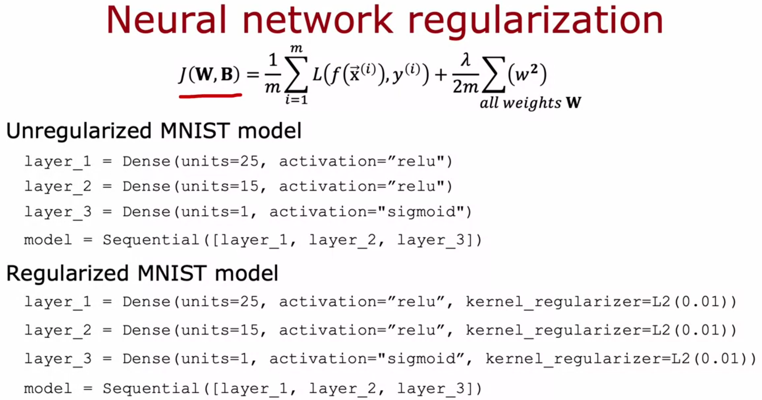

Forward propagation is the process in a neural network where the input data is passed through the network’s layers to generate an output.

Adam (Adaptive Moment estimation) algorithm (optimizer) allows us to train NN much faster than Gradient Descent. Adam algorithm can adjust the learning rate automatically. Adam algorithm become a de-facto standard in how practitioners train their neural networks.
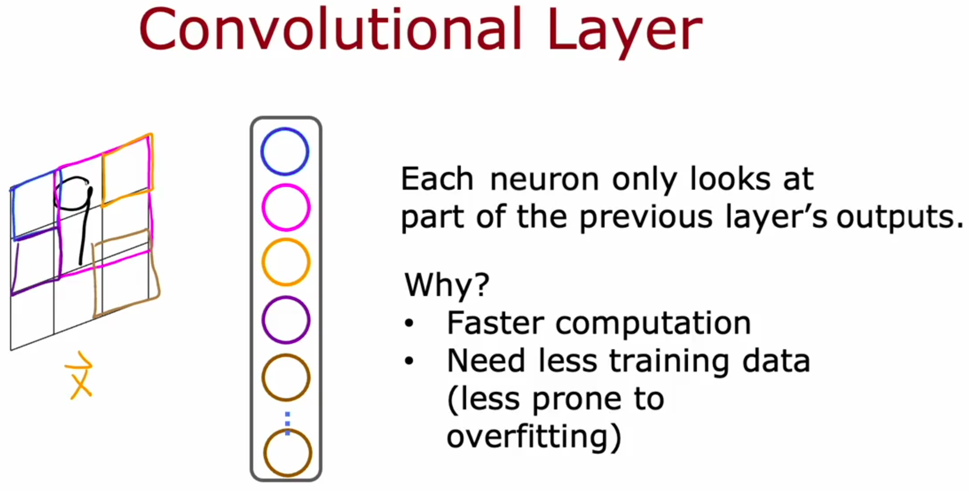

Dense layer: A linear operation in which every input is connected to every output by a weight (so there are n_inputs * n_outputs weights - which can be a lot!). Generally followed by a non-linear activation function
Convolutional layer: A linear operation using a subset of the weights of a dense layer. Nearby inputs are connected to nearby outputs (specifically - a convolution 920 ). The weights for the convolutions at each location are shared. Due to the weight sharing, and the use of a subset of the weights of a dense layer, there’s far less weights than in a dense layer. Generally followed by a non-linear activation function

Softmax Regression is the generalization of Logistic Regression
Linear, Sigmoid and ReLU are by far the most commonly used activation functions in NN.
Choosing activation function for output layer:
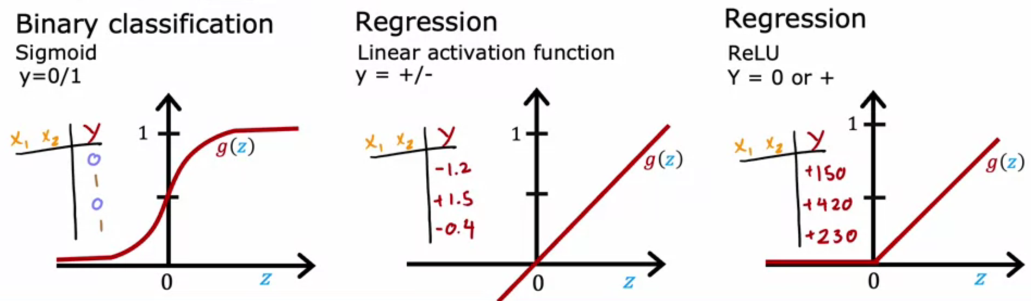
Andrew NG suggests using ReLU for the hidden layers of NN almost always.

Unsupervised Learning
No labels, there are only inputs available. Our job is to find patterns in the data. Clustering algorithm for example groups inputs into individual groups (outputs, categories).
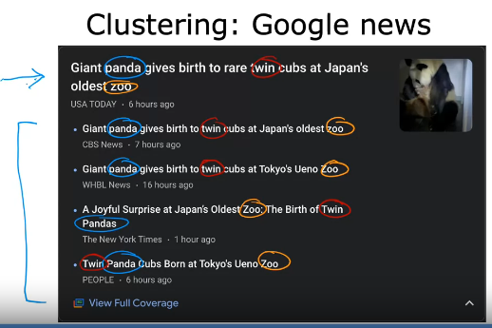
Another algorithm of Unsupervised learning is Anomaly Detection where we find unusual data in a given dataset. Anomaly Detection, for example, is used for the case of fraud detection in a finance industry.

Yet another algorithm is Dimensionality Reduction. Dimensionality Reduction helps you pick a dataset and compress it into much smaller dataset. Is is, basically, transformation of high-dimensional space data into a low-dimensional space data retaining meaningful properties of the original data.
To end up with a good ML model, train your data on serveral models at once and choose the best one, the model performing the best on your test set.
________________________________________________________________________________

TERMINOLOGY
- y-hat is an estimated value, while y is the actual label

